

**ANL 252**

**PYTHON FOR DATA ANALYTICS**

**End-of-Course Assessment**

**January 2023 Presentation**

**Submitted by:**

|  |  |
| --- | --- |
| **Name** | **PI Number** |
| Chong Xin Hui Sandy | W2110447 |

**Tutorial Group: T05**

**Instructor’s Name: MUNISH KUMAR**

**Submission Date: 06 March 2023**

**Question 1**

Jupyter Python code:-

import pandas as pd

import numpy as np

import matplotlib.pyplot as plt

import seaborn as sns

# Question 1

# Load the ECA dataset and replace missing values with NaN

eca_df = pd.read_csv("ECA.csv", na_values=["", "???", "Unkn"])

# Find columns with missing values and print their names

print("Columns with missing values:")

for col in eca_df.columns:

if eca_df[col].isna().sum() > 0:

print(col)

which resulted in following python output:-

Columns with missing values:

Claim_ID

Actual

Terms

**Question 2**

Jupyter Python code:-

# Question 2

# Drop rows where Actual is missing since we cannot predict the payout amount

eca_na = eca_df.dropna(subset=["Actual"]).copy()

# Find rows where Claim_ID is missing and replace with next sequential ID

missing_claim_ids = eca_na["Claim_ID"].isna()

last_claim_id = eca_na.loc[~missing_claim_ids, "Claim_ID"].max()

eca_na.loc[missing_claim_ids, "Claim_ID"] = range(

last_claim_id + 1, last_claim_id + 1 + missing_claim_ids.sum()

)

# Find the most probable Term value and replace missing values

most_probable_term = eca_na["Terms"].value_counts().idxmax()

eca_na["Terms"] = eca_na["Terms"].fillna(most_probable_term)

# Check the number of missing values

num_missing = eca_na.isna().sum().sum()

0

**Question 3**

Jupyter Python code:-

# Question 3

# Convert date columns to datetime

eca_na["Planned"] = pd.to_datetime(eca_na["Planned"],

format="%d/%m/%Y")

eca_na["Created"] = pd.to_datetime(eca_na["Created"], format="%Y%m%d")

eca_na["Actual"] = pd.to_datetime(eca_na["Actual"], format="%d/%m/%Y %H:%M")

# Combine rare terms into a new category called "UC01"

term_counts = eca_na["Terms"].value_counts(normalize=True)

rare_terms = term_counts[term_counts < 0.01].index

eca_na.loc[eca_na["Terms"].isin(rare_terms), "Terms"] = "UC01"

# Convert Amount column to float and replace 'O' with '0'

eca_na["Amount"] = eca_na["Amount"].str.replace("O",

"0").astype(float)

**Question 4**

Jupyter Python code for the first data insight:-

# Question 4.1

# Calculate the average claim amounts per policy term

avg_claim_amounts = eca_na.groupby("Terms")["Amount"].mean()

# Plot the results

plt.figure(figsize=(8, 5))

plt.title("Average Claim Amounts by Policy Terms")

plt.bar(x=avg_claim_amounts.index, height=avg_claim_amounts.values)

plt.show()

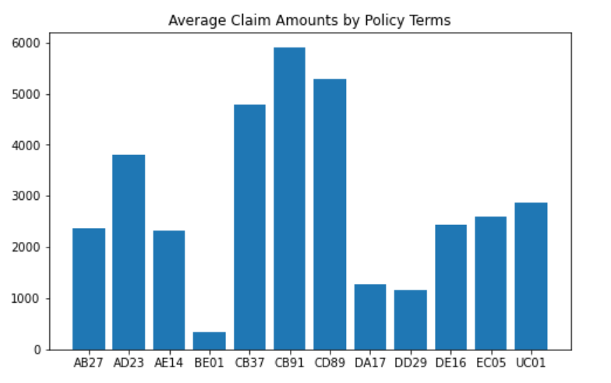

The average claim amounts for each term varied dramatically.

As evidenced by the above graph, BE01, DD29 and DA17 claims have a relatively low average claim amount.On the other hand, CB37, CB91 and CB89 claims have a high claim amount.

If the claim amount influences the time it takes the corporation to pay out the claim, we may have multicollinearity in the data, which we will further analyse below.

Jupyter Python code for the second data insight:-

# Question 4.2

# Calculate claim delay in days and plot it against claim amount

eca_na["Claim_Delay"] = (eca_na["Actual"] - eca_na["Planned"]).dt.days

plt.figure(figsize=(8, 5))

plt.title("Claim Amount vs. Claim Delay")

plt.scatter(x=eca_na["Amount"], y=eca_na["Claim_Delay"])

plt.xlabel("Claim Amount")

plt.ylabel("Claim Delay (days)")

plt.show()

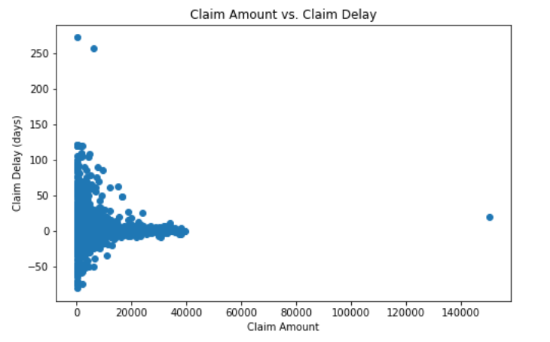

We can observe that claim amount does influences payout delay to a limited extent. The bigger the claim amount, the closer it is to zero. This implies that when the claim amount is significant, the insurance company is more concerned about timeliness.

We may also deduce that words with a high average claim amount, such as CB37 and CB91, are more likely to be on time, whereas terms with a low average claim amount, such as BE01, are more likely to be either early or late.

Jupyter Python code for the third data insight:-

# Question 4.3

# Check if the average claim amount differs significantly by other variables as well

for col in ["Type", "Region", "Category"]:

avg_claim_amt_by_col = eca_na.groupby(col)["Amount"].mean()

plt.figure(figsize=(8, 5))

plt.title(f"Average Claim Amounts by Policy {col}")

plt.bar(x=avg_claim_amt_by_col.index,

height=avg_claim_amt_by_col.values)

plt.show()

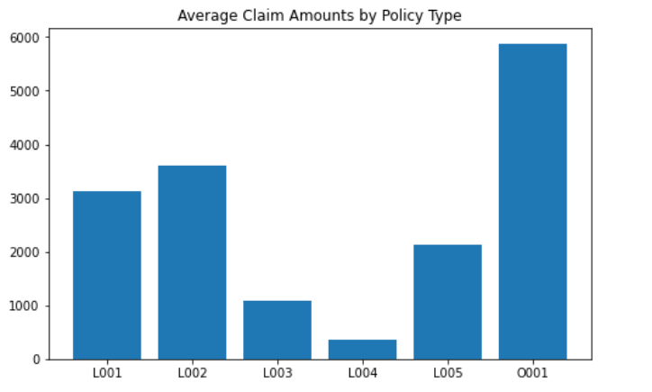

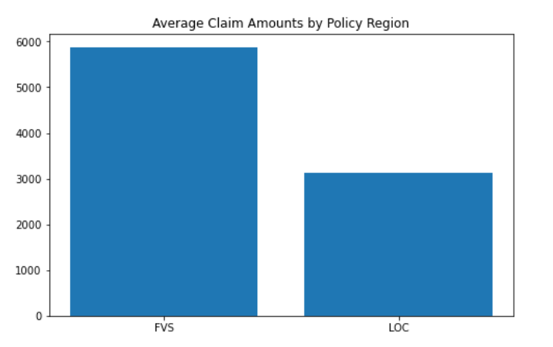

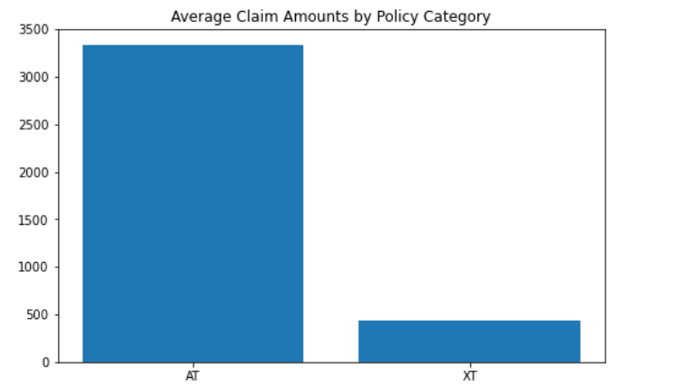

We can observe that there is a significant difference between average claim amounts in each class of variable for each category variable. This provides us confidence that the data has enough variation for the model to learn.

**Question 5**

Jupyter Python code:-

# Question 5

import pandas as pd

from sklearn.model_selection import train_test_split

from sklearn.preprocessing import MinMaxScaler

# Prepare the data for regression

reg_data = eca_na.drop(columns=["Claim_ID", "Policy_No", "Name",

"Planned", "Actual", "Created"])

reg_data = pd.get_dummies(reg_data)

reg_variables = reg_data.drop(columns="Delay")

reg_target = reg_data["Delay"]

# Split the data into training and testing sets

X_train, X_test, y_train, y_test = train_test_split(reg_variables,

reg_target, test_size=0.4)

# Scale the data for use in linear regression

scaler = MinMaxScaler()

scaler.fit(X_train)

X_train_scaled = scaler.transform(X_train)

X_test_scaled = scaler.transform(X_test)

# Linear Regression

from sklearn.linear_model import LinearRegression

from sklearn.metrics import r2_score

# Fit a linear regression model to the training data

lin_reg = LinearRegression()

lin_reg.fit(X_train_scaled, y_train)

# Predict the target variable using the trained model

train_pred = lin_reg.predict(X_train_scaled)

# Calculate the r-squared score on the training data

r2_train = r2_score(y_train, train_pred)

print("Training r-squared score:", round(r2_train, 4))

Model r2 0.139

The model performs badly on the data, which means that the coefficients of the model would not be reliable as well

for column, coef in zip(variables.columns, lr.coef_):

print(f"{column}: {coef:.4f}")

Amount: -10.6717

Paid_Yes: 0.0000

Category_AT: -65.1169

Category_XT: 65.1169

Terms_AB27: -0.4704

Terms_AD23: 2.7060

Terms_AE14: 1.3298

Terms_BE01: -6.1040

Terms_CB37: 3.1676

Terms_CB91: 7.4293

Terms_CD89: 2.0466

Terms_DA17: 0.6672

Terms_DD29: -11.7280

Terms_DE16: 2.1393

Terms_EC05: -2.4136

Terms_UC01: 1.2302

Region_FVS: -1.3297

Region_LOC: 1.3297

Type_L001: -3.8960

Type_L002: 2.4302

Type_L003: 0.6682

Type_L004: 5.1181

Type_L005: -2.9909

Type_O001: -1.3297

plt.figure(figsize = (12, 9))

plt.title("Coefficients of Linear Regression")

plt.bar(x = variables.columns, height = lr.coef_)

plt.xticks(rotation = 315)

plt.show()

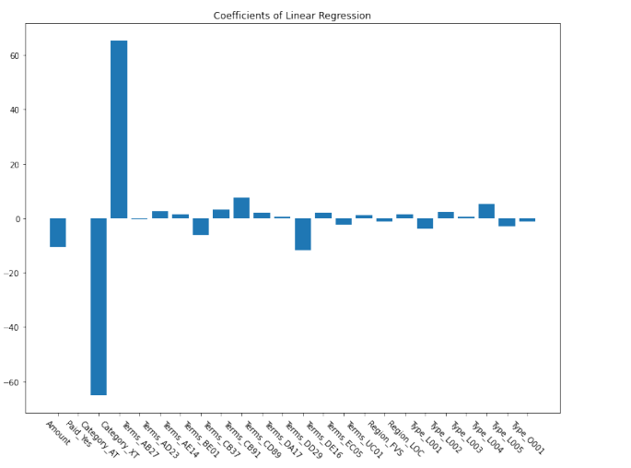

**Question 6**

We can observe that category has the greatest impact on payment delay for the trained model. We may deduce that category AT is likely to be early since it has a significant negative coefficient, indicating that policies in category AT would have a low delay value, thus being early.

Due to its high positive coefficient, category XT is typically late.